Creating a REST API User Account
Customer Guidance

Setting up a Partner/School for REST API
School Access
The only User Role which has access to manage the WEB API Company access is the out-of-the-box role of School Administrator.
Partner/School User Id
- Log in as School Administrator
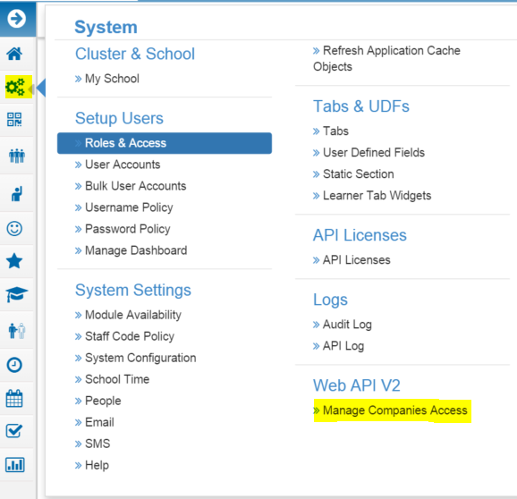
- Go to System | Web API V2 | Manage Companies Access

- Click on the + to add a new record
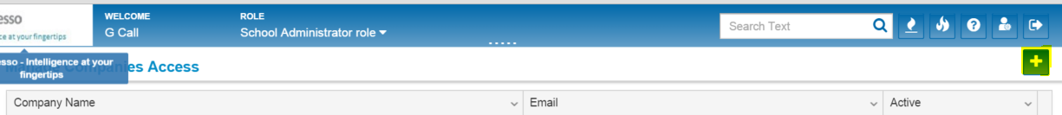
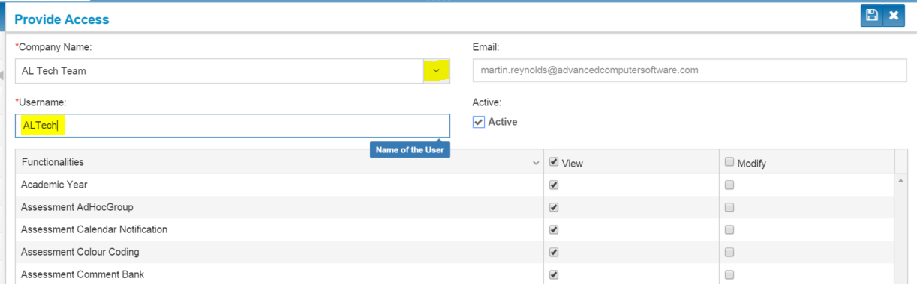
- Select the Company from the drop down list

- Enter a Username – this is the username your Partner/School will use for API Authentication
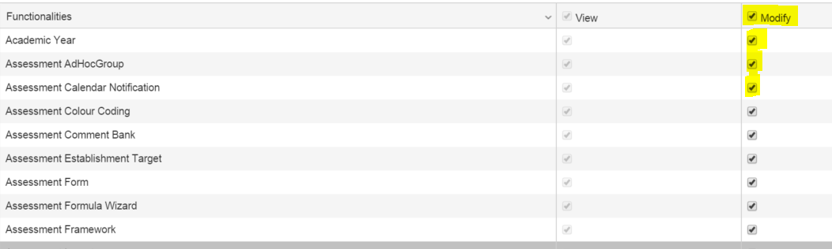
- If the Partner will be writing/importing data into Progresso then check the required modules under Modify
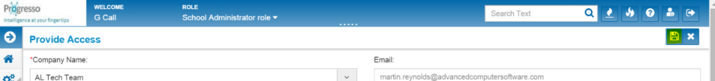
- Click Save

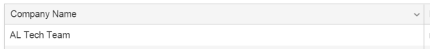
- You will see the record has been added to the list

At this stage, an email will be sent out to the Partner contact with a User Id and password which they can then use to access the REST API.
For use, the password must be encoded. However, some special characters do not encode correctly and an authentication error is received. If this happens, please contact sally.robinson@oneadvanced.com who will reset the password for you.

